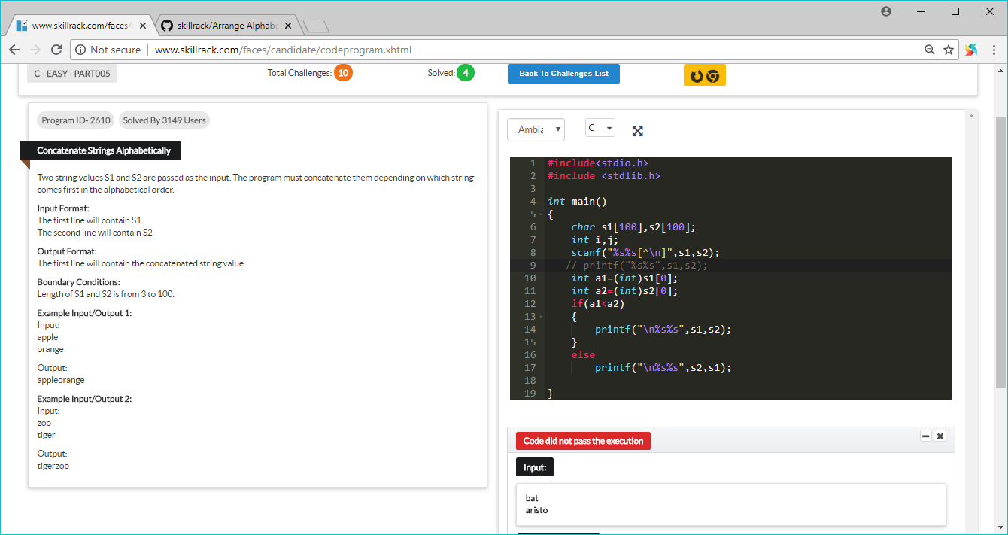

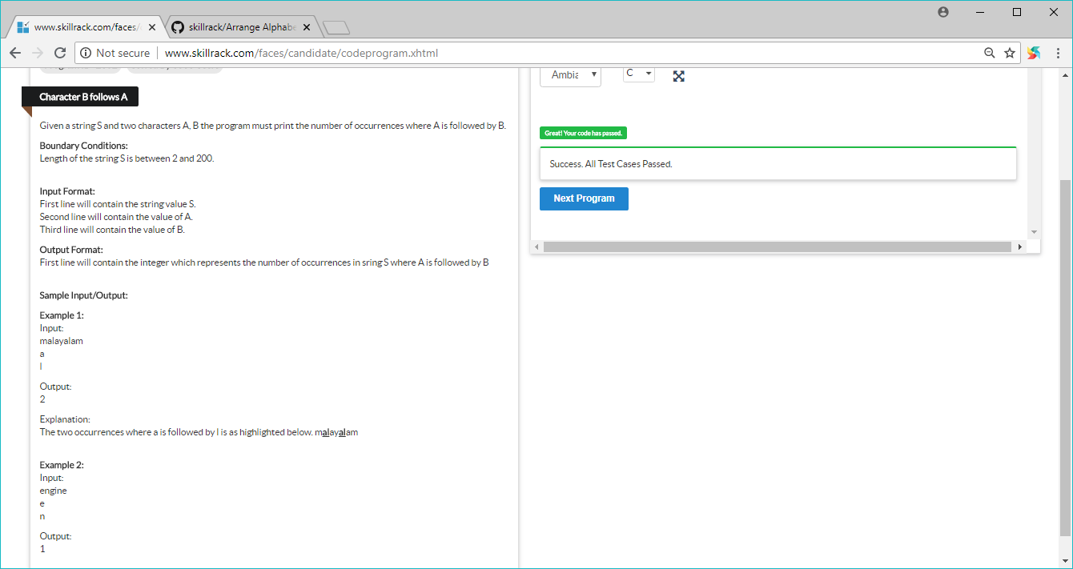

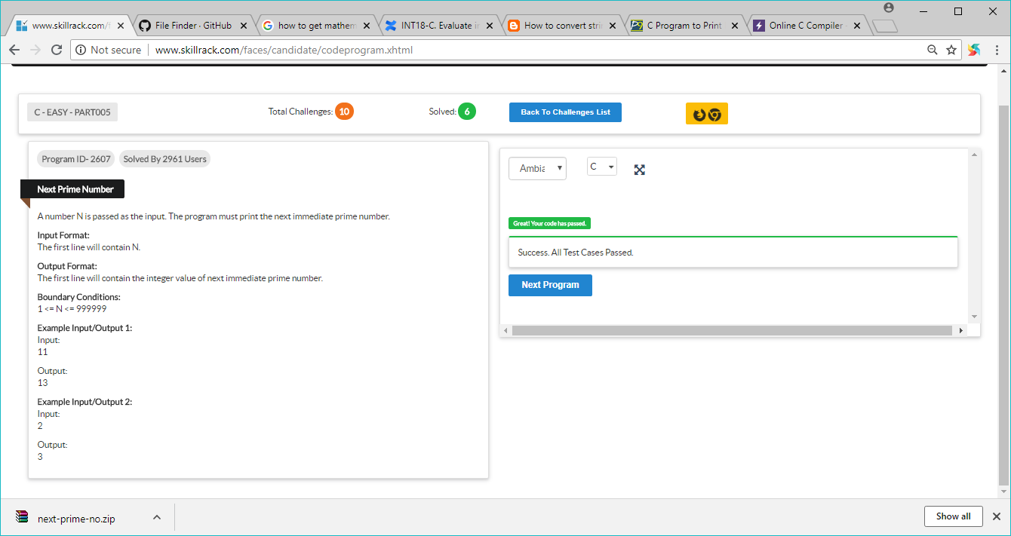

#include <stdio.h>

int main()

{

int n,i,fact,j,k=0,a[100000];

printf("Enter the Number");

scanf("%d",&n);

printf("Prime Numbers are: \n");

for(i=1; i<=n+10000; i++)

{

fact=0;

for(j=1; j<=n+10000; j++)

{

if(i%j==0)

fact++;

}

if(fact==1)

{

a[k]=i;

k++;

}

else if(fact==2)

{

a[k]=i;

k++;

}

}

for(i=0;i<n+1;i++)

{

k=i;

if(a[k]>n)

{

printf("%d ",a[k]);

break;

}

}

return 0;

}

